- Purpose
  - The purpose of this document is to describe the procedure for assembling the handle on the Crewman High and Low Speed machines.
- Scope
  - This SOP applies to all equipment assembly team members. The process applies to the following machine ID’s:
E083015EQM0600BE1200 – Crewman 1600 RPM Cord-Electric Burnisher
E083015EQM0607BE1200 – Crewman 1600 RPM Cord-Electric Burnisher-Canada
E083016EQM0600BE1200 – Crewman 2000 RPM Cord-Electric Burnisher
E083016EQM0600BE1200 – Crewman 2000 RPM Cord-Electric Burnisher-Canada
E083013EQM0600BE1200 – Crewman 17HD Heavy Duty Floor Machine 17”
E083013EQM0607BE1200 – Crewman 17HD Heavy Duty Floor Machine 17”-Canada
E083014EQM0600BE1200 – Crewman 20HD Heavy Duty Floor Machine 20”
E083014EQM0607BE1200 – Crewman 20HD Heavy Duty Floor Machine 20”-Canada
E085812EQM0600BA1000 – Basic Dragon Dustless Floor Machine
E083010EQM0600BE1200 – Foreman 20DS Dual Speed Floor Machine 20”
E083010EQM0607BE1200 – Foreman 20DS Dual Speed Floor Machine 20”-Canada
- Responsibilities
  - The operations manager/supervisor is responsible for enforcing this SOP.
- Materials
  - The proper materials needed for this process are listed on the machine work order.
  - Hand/Power Tools
- Definitions

- Procedure
  - Start with a handle tube (89954).

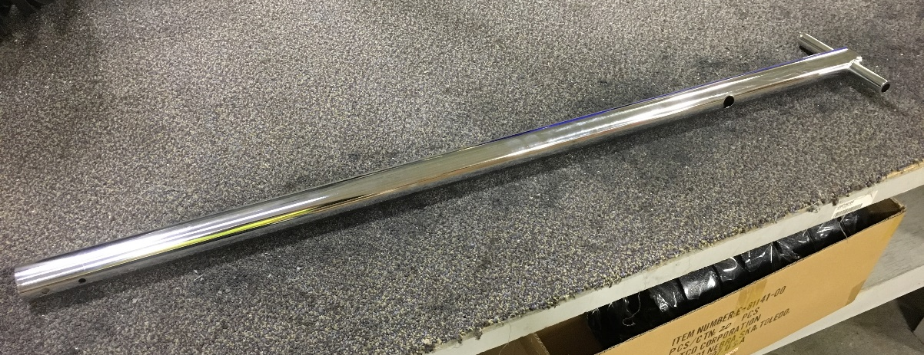

  - Insert a rubber grommet (83519) into the hole on the handle tube.
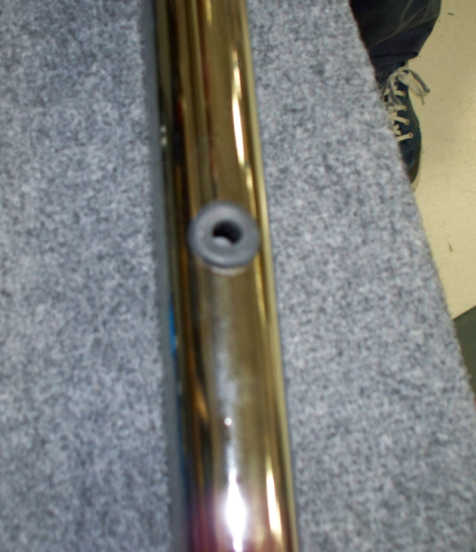

  - Feed the handle cord (83132) into the handle tube. Feed the end with the wires in through the grommet first. As you are feeding the harness through try to hold the grommet so that the harness does not pull it into the tube. Pull the harness through until a length approximately the same as the photo on the right sticks out of the top of the tube.
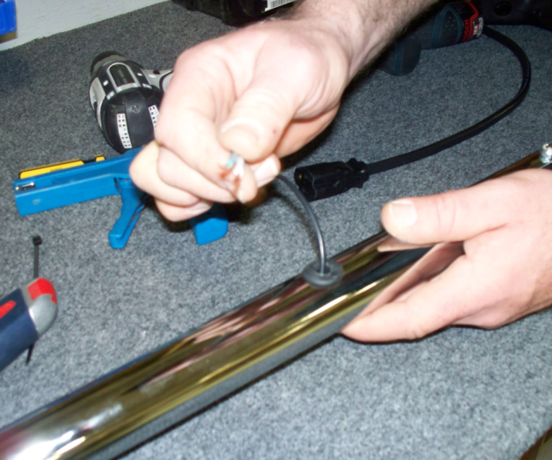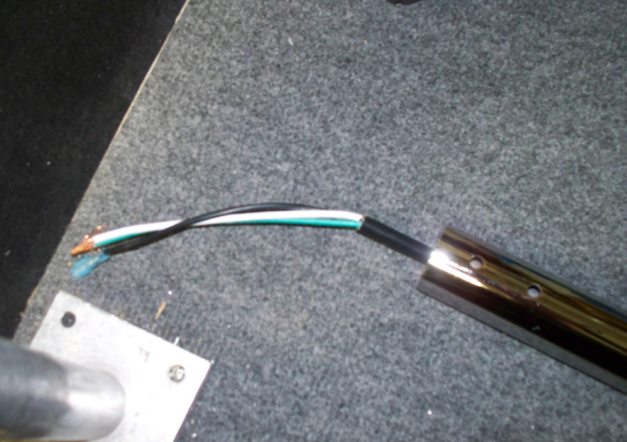

  - Now the cord hook (83137) needs to be installed. First, place the cord hook onto the tube fixture located on the handle table. Gently pry the cord hook open to allow it to more easily slide onto the handle tube. Be careful not to pry to much as the piece will break.
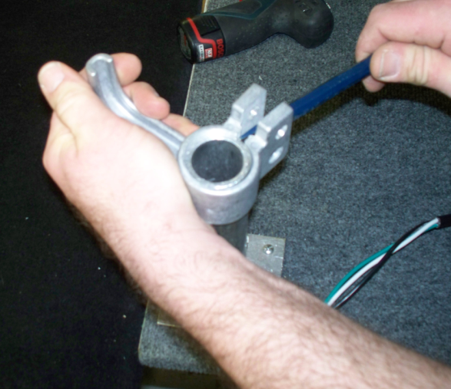

  - Slide the cord hook on the handle tube in the orientation shown.
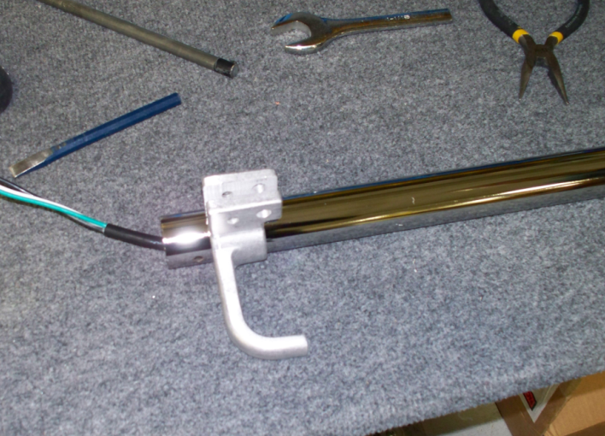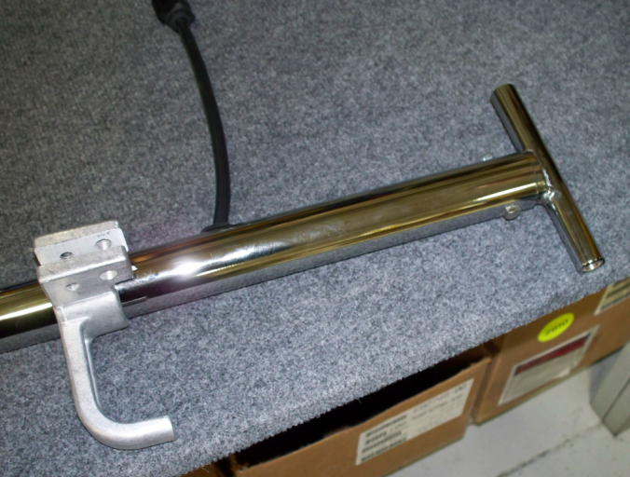

  - Take 2 spring clips (83270) and loop an end from the extension spring (83130) over the tab on each one. Pliers can be used to smash down the tab so that the spring does not fall off.

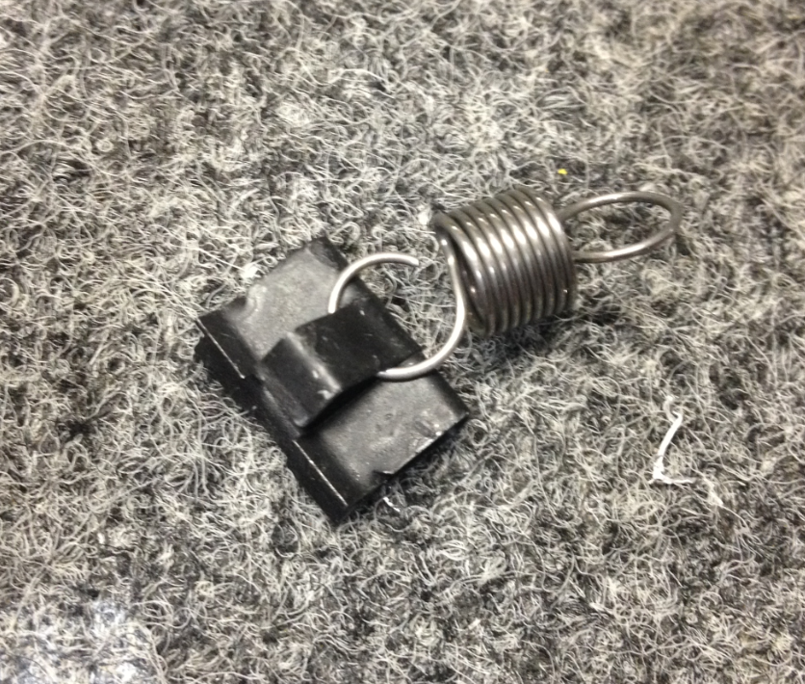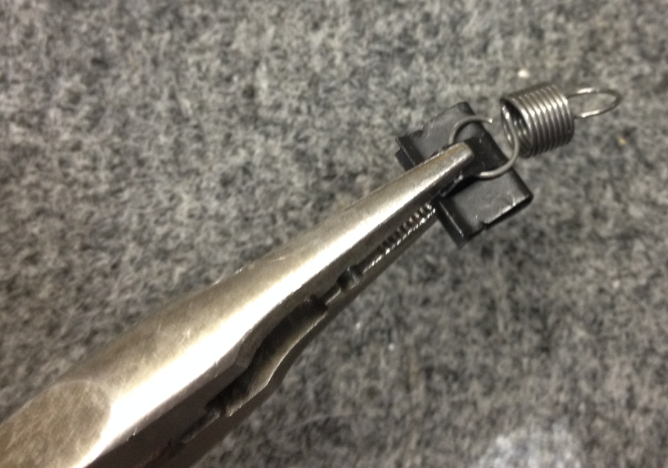

  - Now we will begin assembly of the top of the handle. Begin by installing the spring clips onto the switch box (82750) in the locations and the orientations shown.
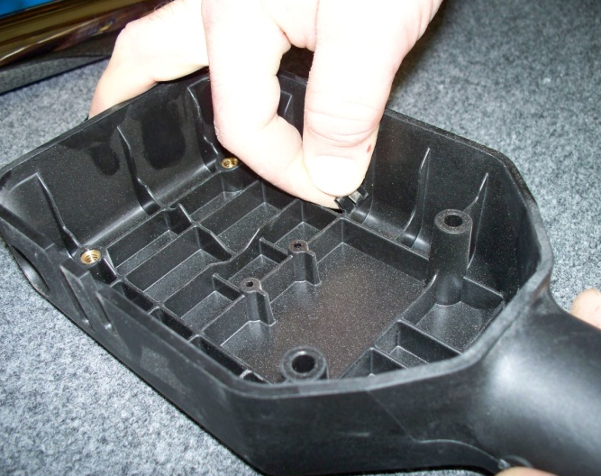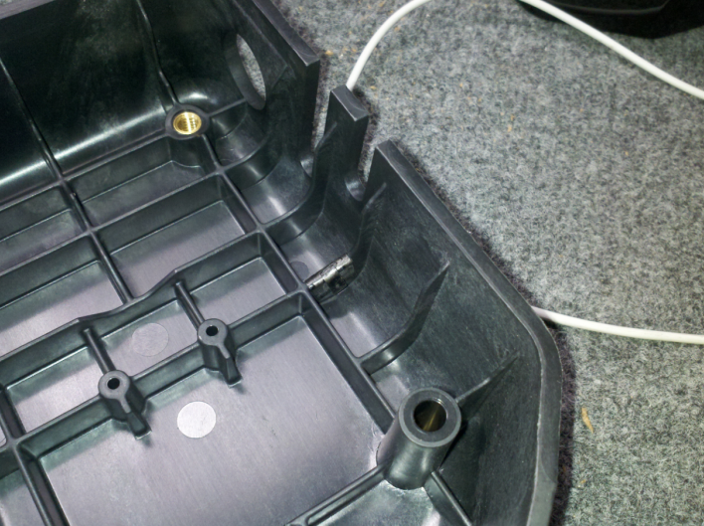

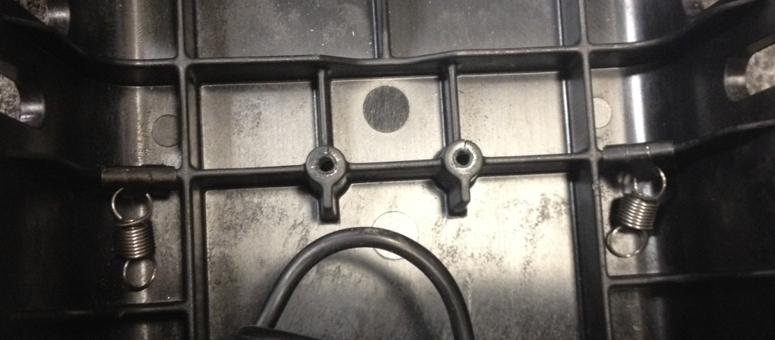

  - Slide the handle grip tube (83451) through the hole in the top of the handle switch box. Slide the handle grips (83127) into place as shown.
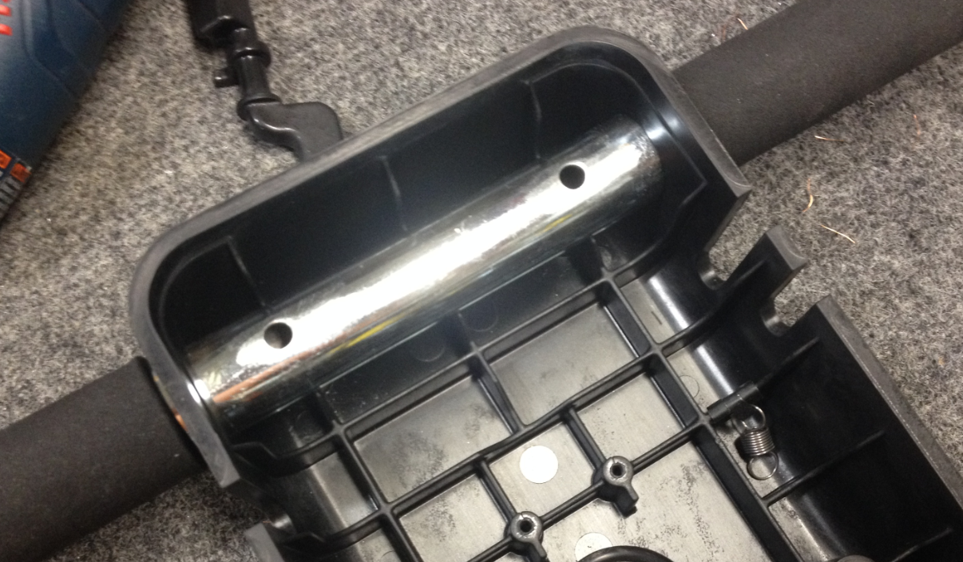
Handle Tube
Handle Grips
  - Insert the lower handle tube into the switch box assembly. Feed the pigtail cord through the loop in the switch box.

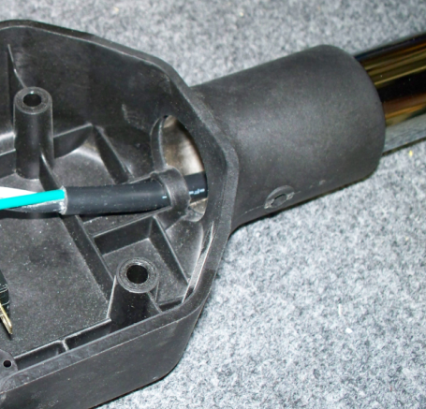

  - Attach the lower handle tube to the switch box using (1) each of a screw (81064), a nut (83520), and a washer (81713). Also attach the ground wire (83521) on the inside of the tube over the screw. The nut will hold it in place. Locate the handle tube so that the pigtail cord coming out of the grommet in the bottom of the tube comes out of the same side as the strain relief hole on the switchbox.
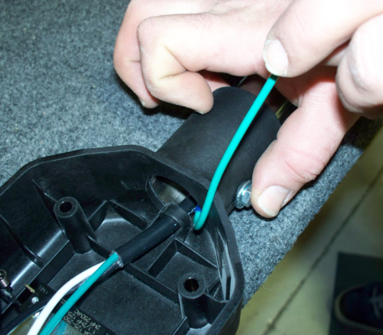
  - Verify that the t-attachment on the bottom of the handle is parallel with the switchbox. If it is not, correct it. You may need to drill out the holes on the handle tube in order to rotate the handle enough.

  - Put a zip tie (83523) onto the pigtail cord inside of the switch box loop. This keeps the pigtail from falling back into the handle.

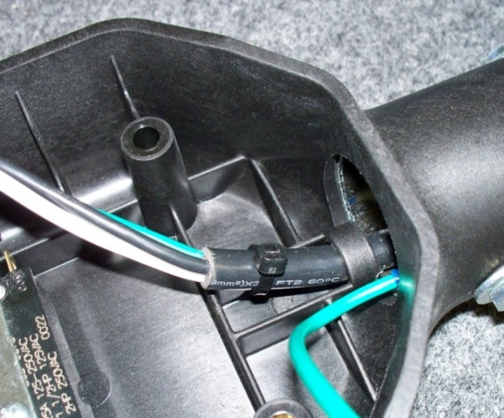

  - This step attaches the handle tube to the switch box in a 2nd location. Use (1) each of a screw (81064), a nut (83520), and a washer (81713) just like before. Verify that the t-attachment and switchbox remain parallel.

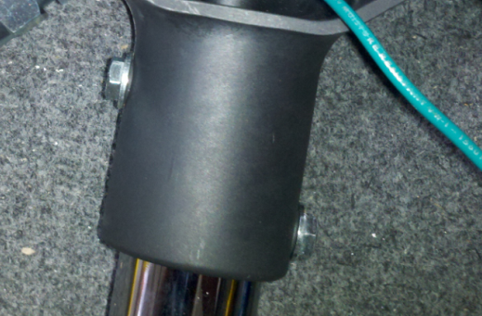

  - Take a cord (83790) and tighten all of the components of the strain relief (89602) with approximately the amount of cord sticking out as shown in the photo below. Ensure that the connection is tight to be sure that the sleeve on the inside bites onto the cord.

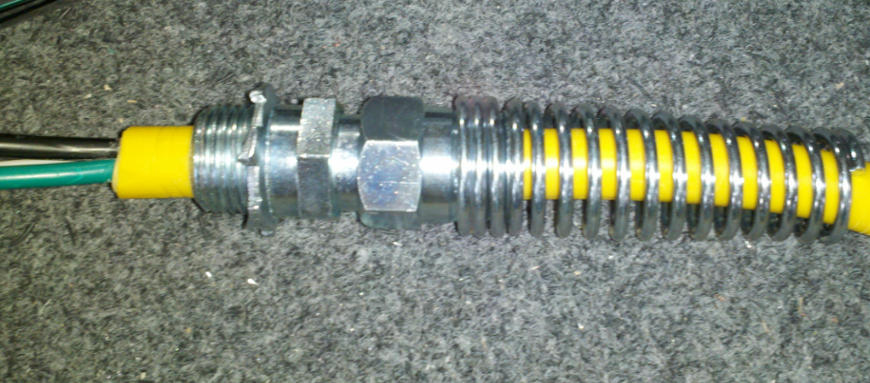
Do not use strain relief nut in this step

  - Insert the threaded end of the strain relief into the hole on the side of the handle switch box. Using a strain relief nut (83789) on the inside of the handle, tighten the assembly together. The nut will bite into the switch box.
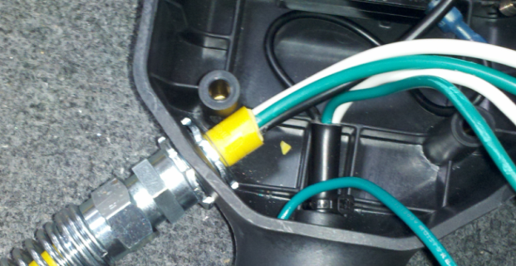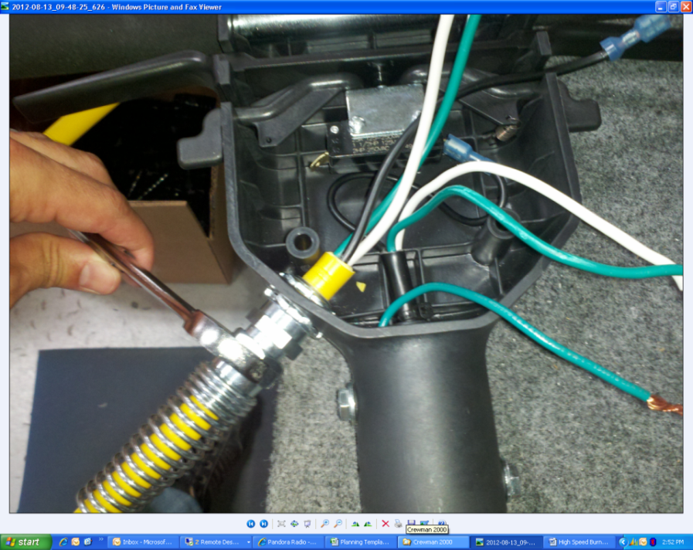
Do not use the 2nd nut shown here
  - Take a switch (85032) and connect the black wire from the yellow power cord to the location shown. Then, connect the black wire from the handle pigtail to the other side of the switch.
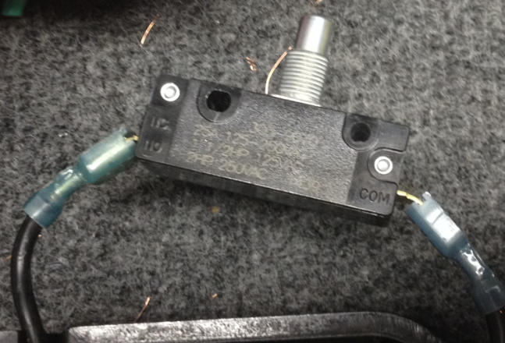
From yellow power cord
From black handle cord
  - Connect the white wire from the yellow power cord to the white wire from the black handle cord using a wire nut (83522). Connect the green wire from the yellow power cord, the green wire from the pigtail, and the green wire going to ground using a wire nut (83522). Tuck all of these wire into the handle tube.

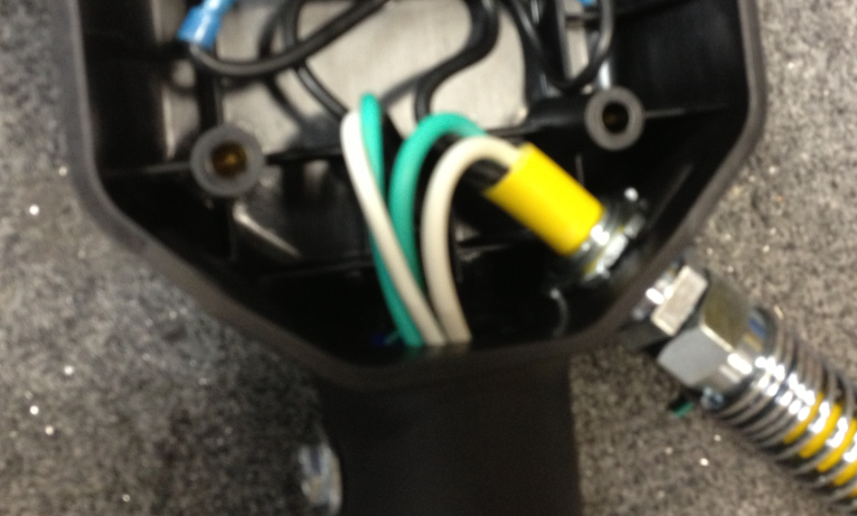

  - Take the conical safety spring (89919) and thread it onto the trigger switch.

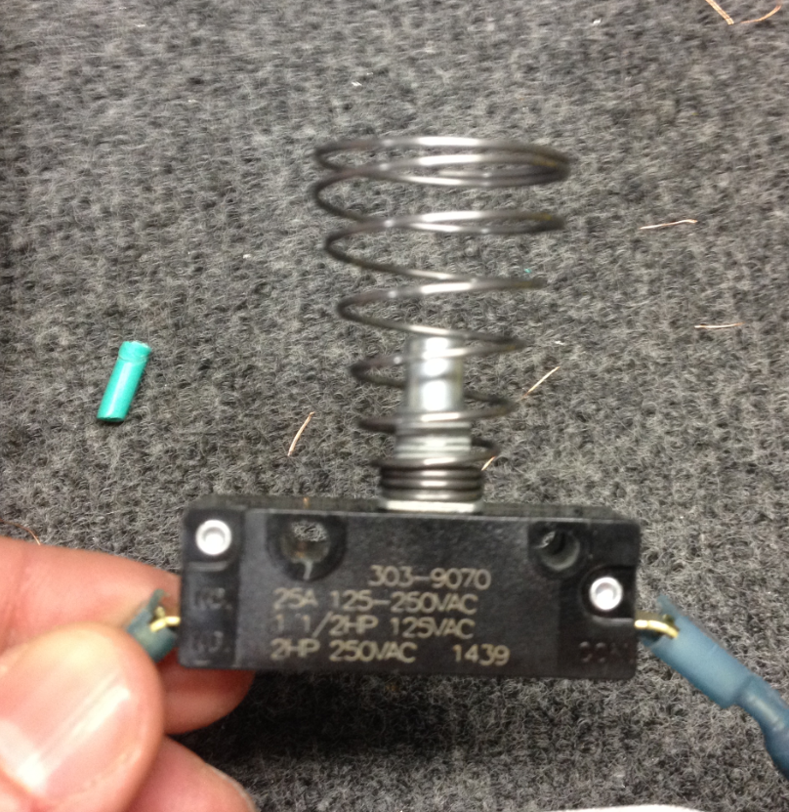

  - Place a switch bracket (89990) over the switch as shown then install the trigger switch into the assembly using 2 screws (83427). Do not overtighten the screws. The clutch on the drill should be at 6 or 7.

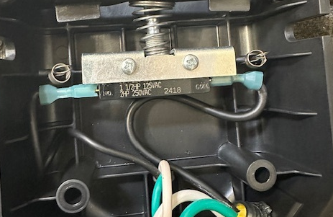
Switch Bracket
  - Install the safety lock (89918) in the orientation shown. The sides of the handle mold may need to be pushed inwards to fit the piece.

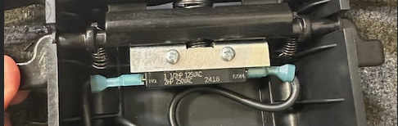

  - Each of the springs need to be stretched under the safety lock and around the finger shown. This is best done using an o-ring pick or needle nose pliers.

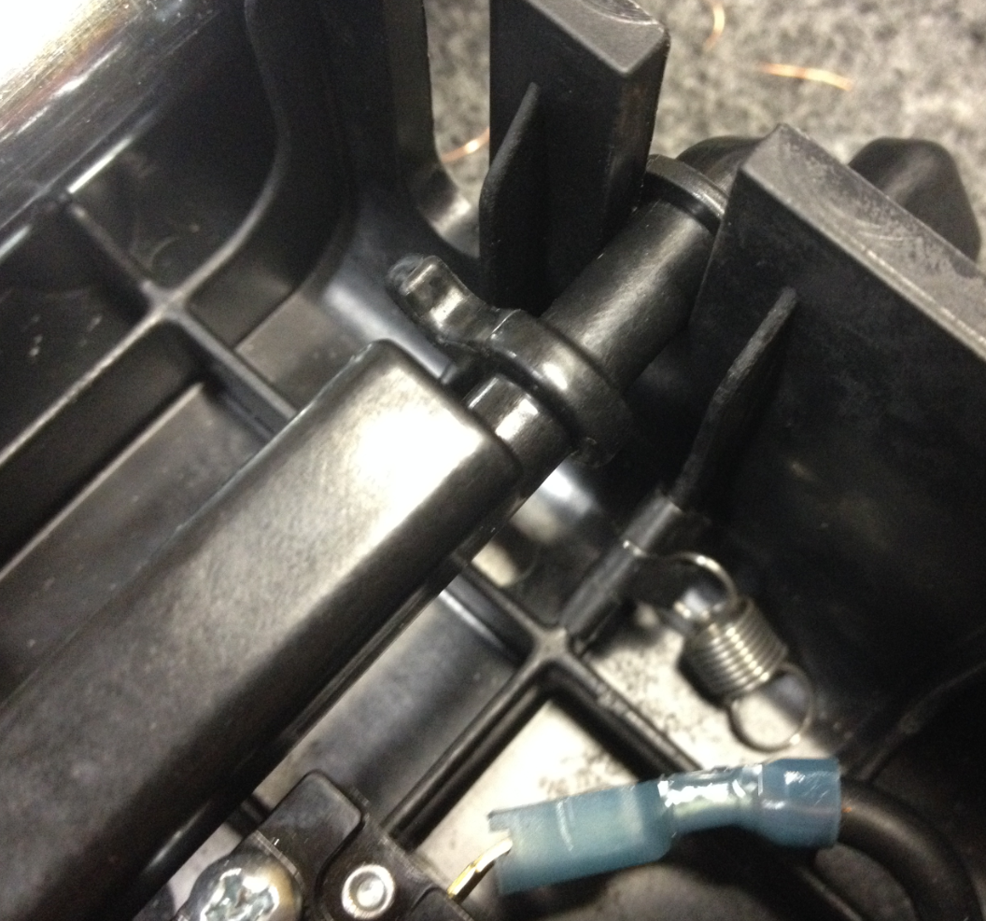
Spring will pass under the safety lock here
Spring will loop over this finger
  - Once the spring has been stretched over the rib and under the safety lock, rotate the finger of the safety lock downwards so that the loop on the spring can be placed over it. Rotating the finger down decreases the distance that the spring needs to be stretched and makes installation much easier.

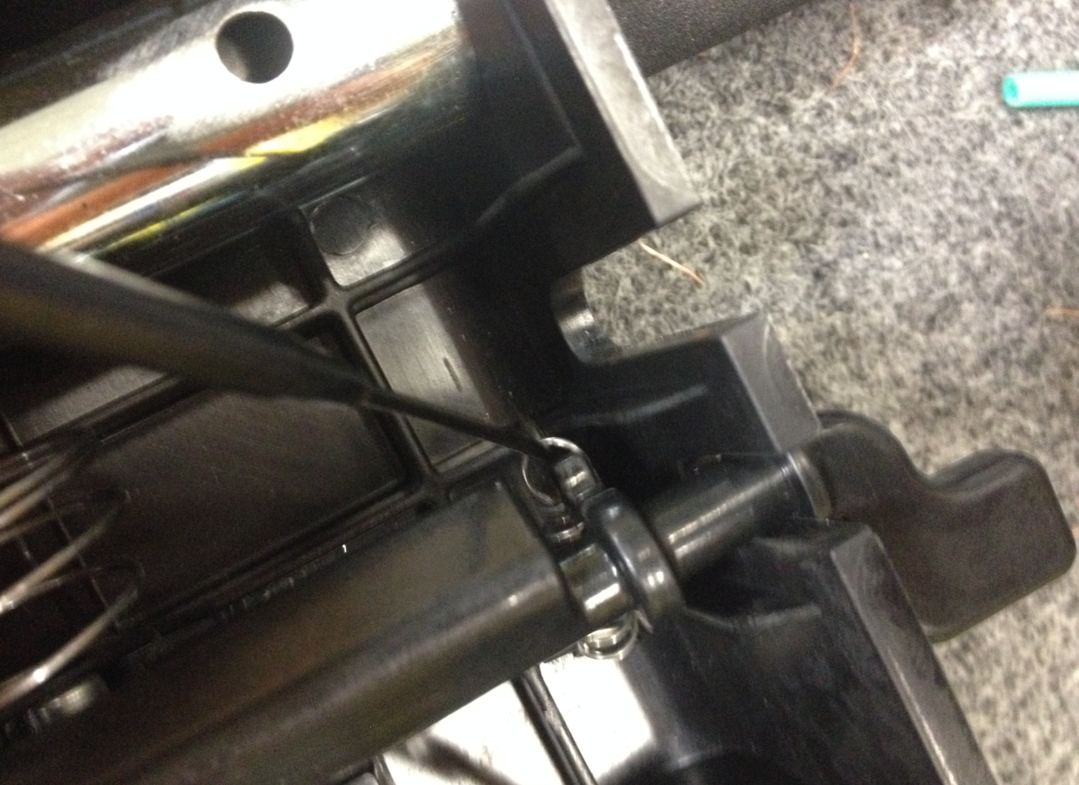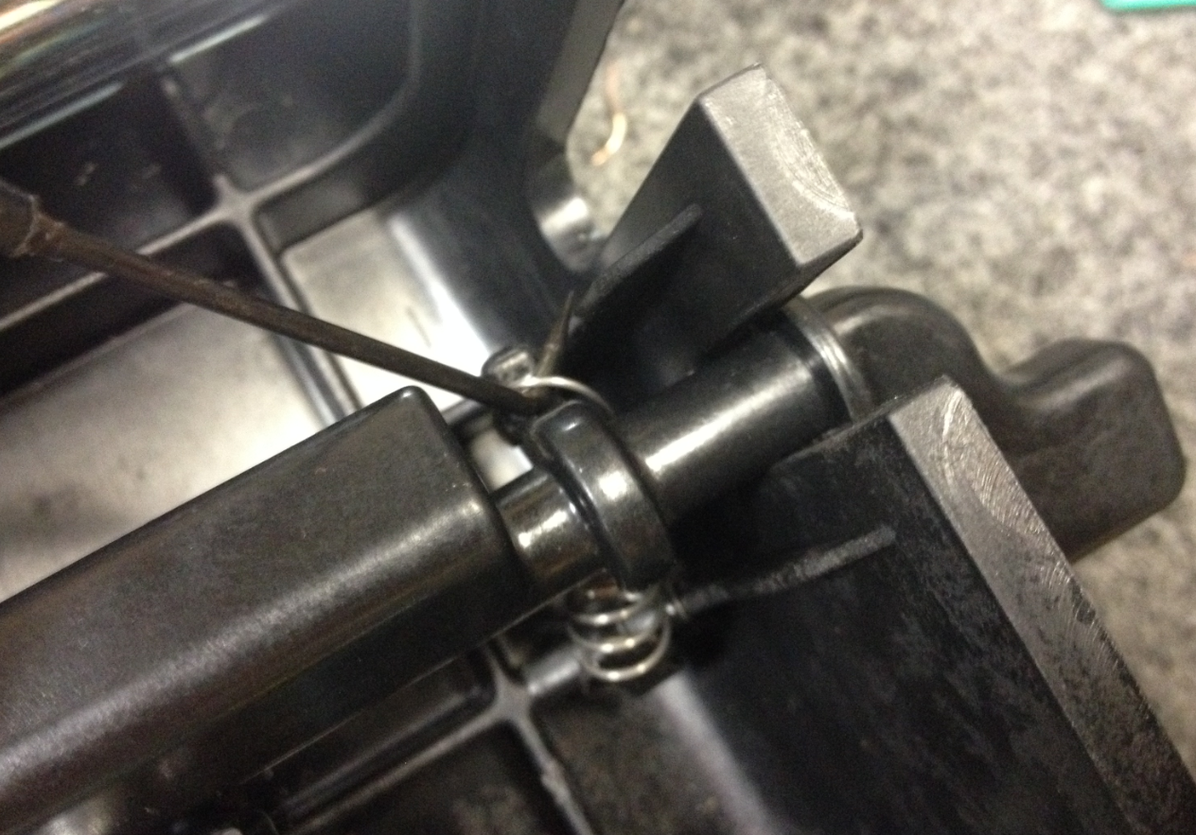
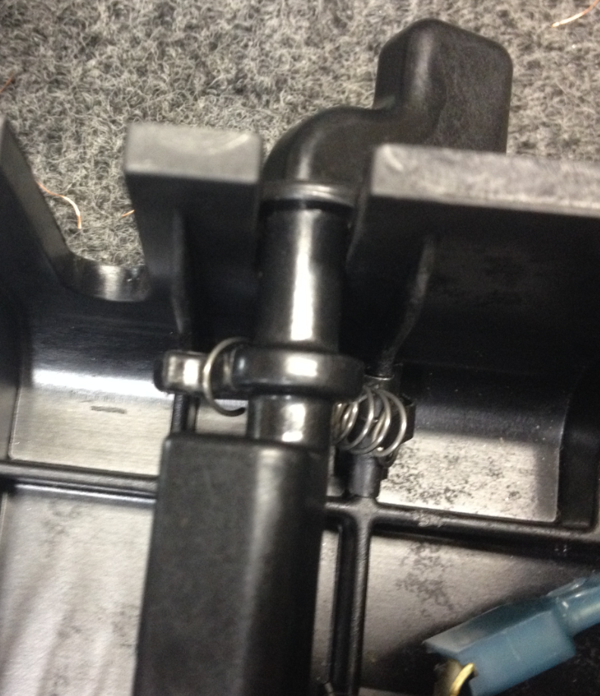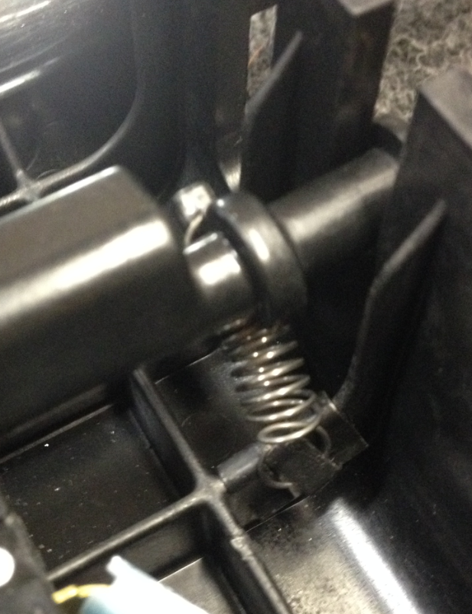
Spring passes under safety lock

  - For all remaining steps, be sure that the safety lock is not allowed to rotate freely since there is spring pressure being applied. This will cause it to spin and the spring will pop off.

  - Repeat the installation for the opposite spring. When rotating the lock, be sure the opposite spring does not come off.

  - Take the right (89917) and left (89916) switch levers and place them in the orientation shown so they can be fit together.
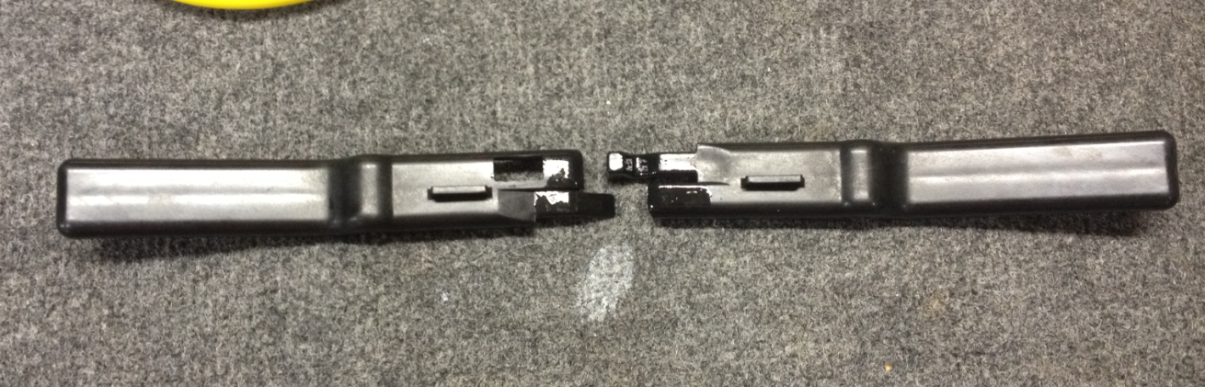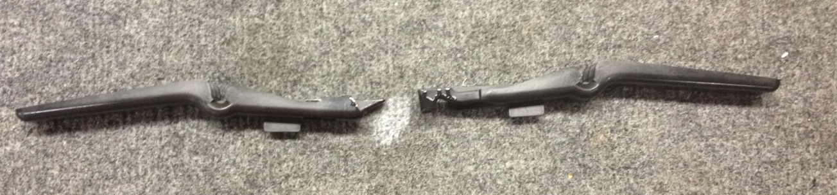
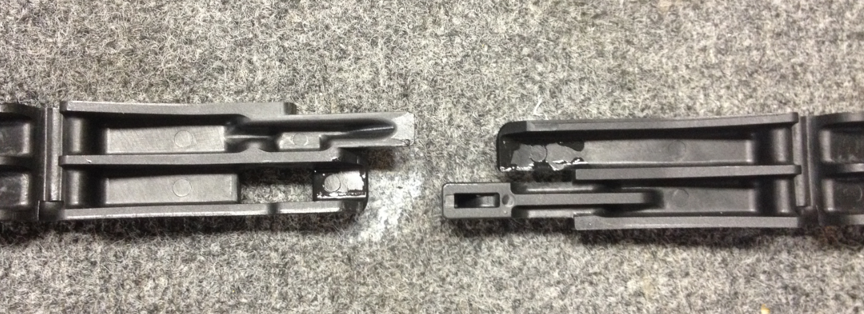
  - Interlock the pieces as shown. This will require a slight scissor motion.

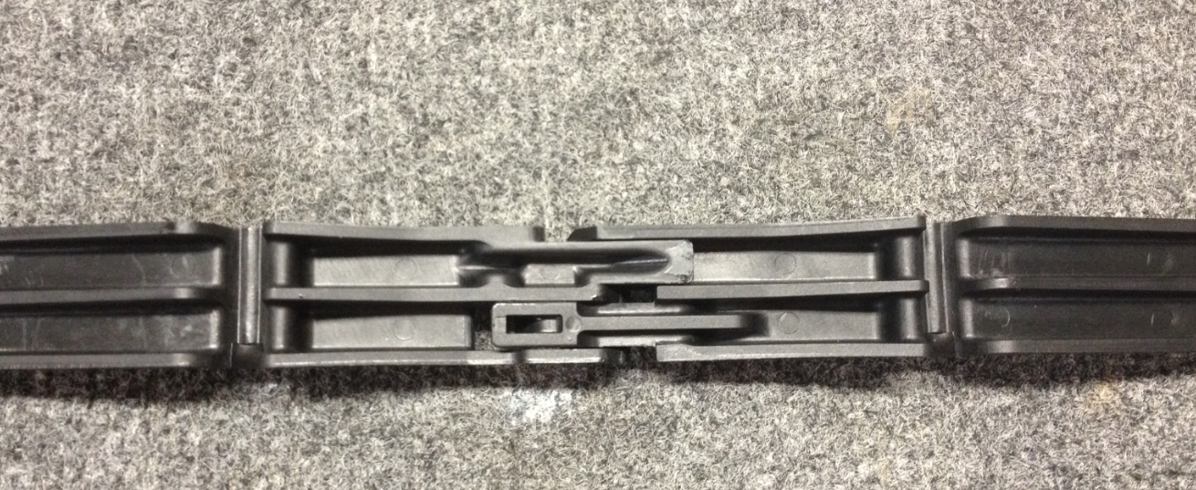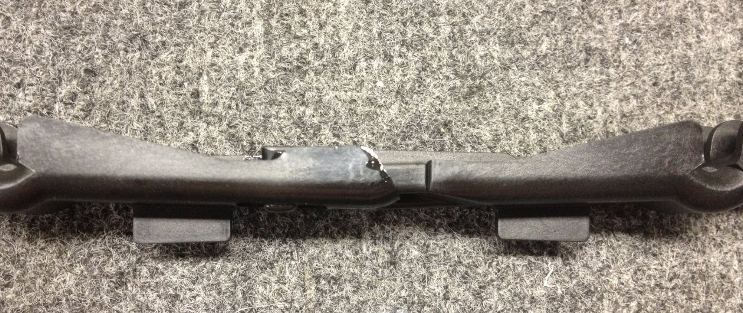
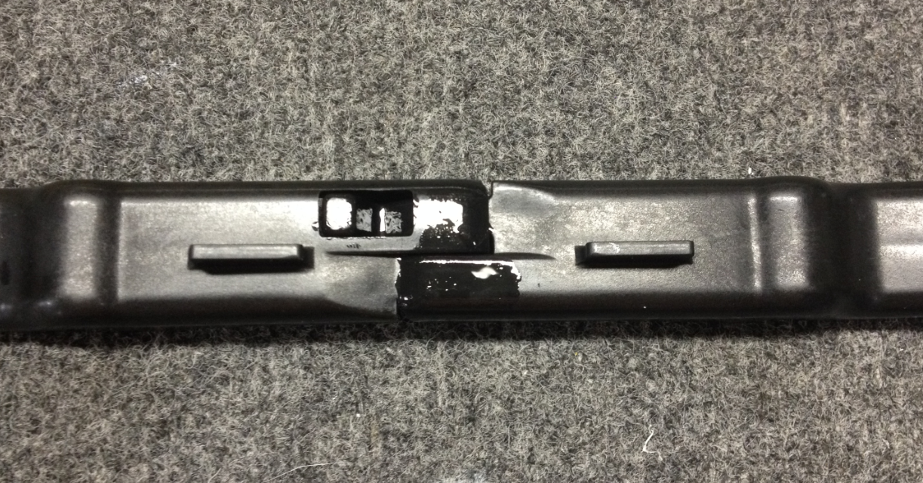
  - Rotate the two pieces up and down to make sure that they slide freely without catching. If they catch, de-flash any edges or apply a light coating of silicone grease onto the sliding surfaces.

  - Orient the trigger pieces to the handle as shown.

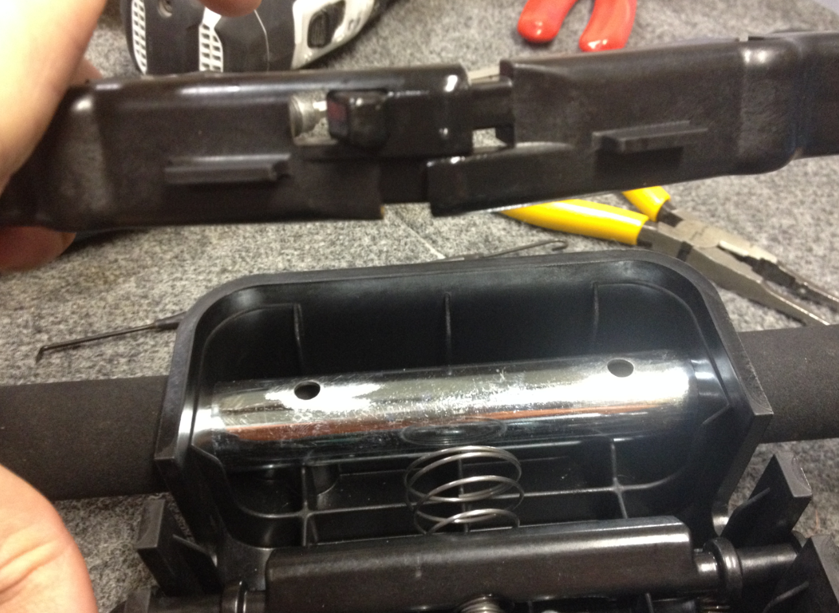

  - Use one finger to compress the conical spring on the switch and then slide the handle into the grooves. Remember to hold the safety lock steady.

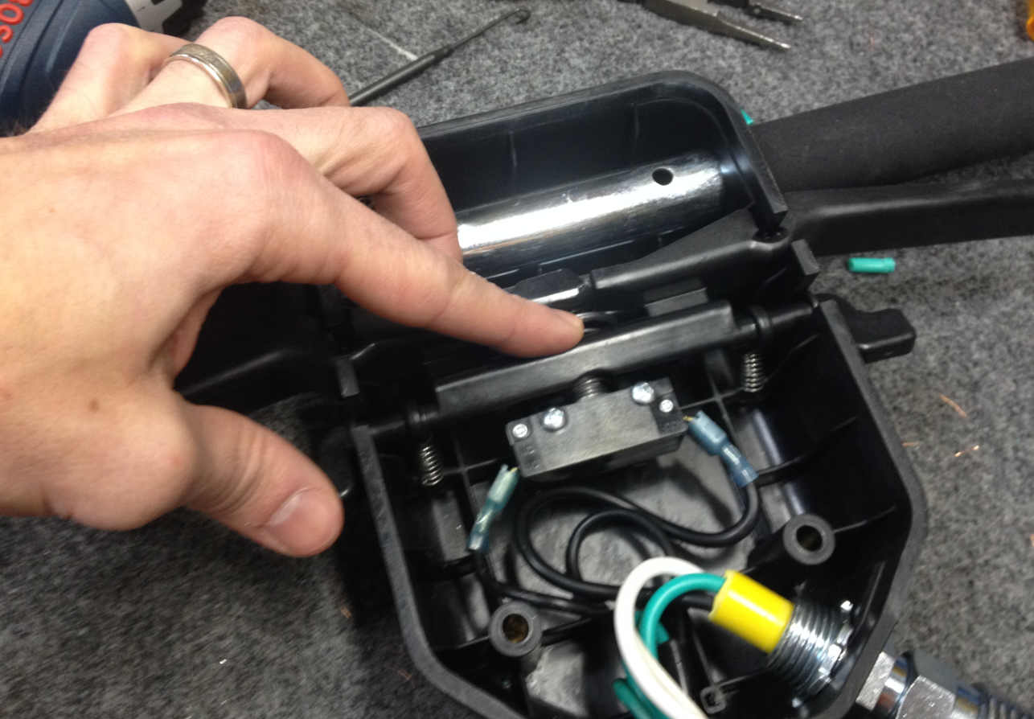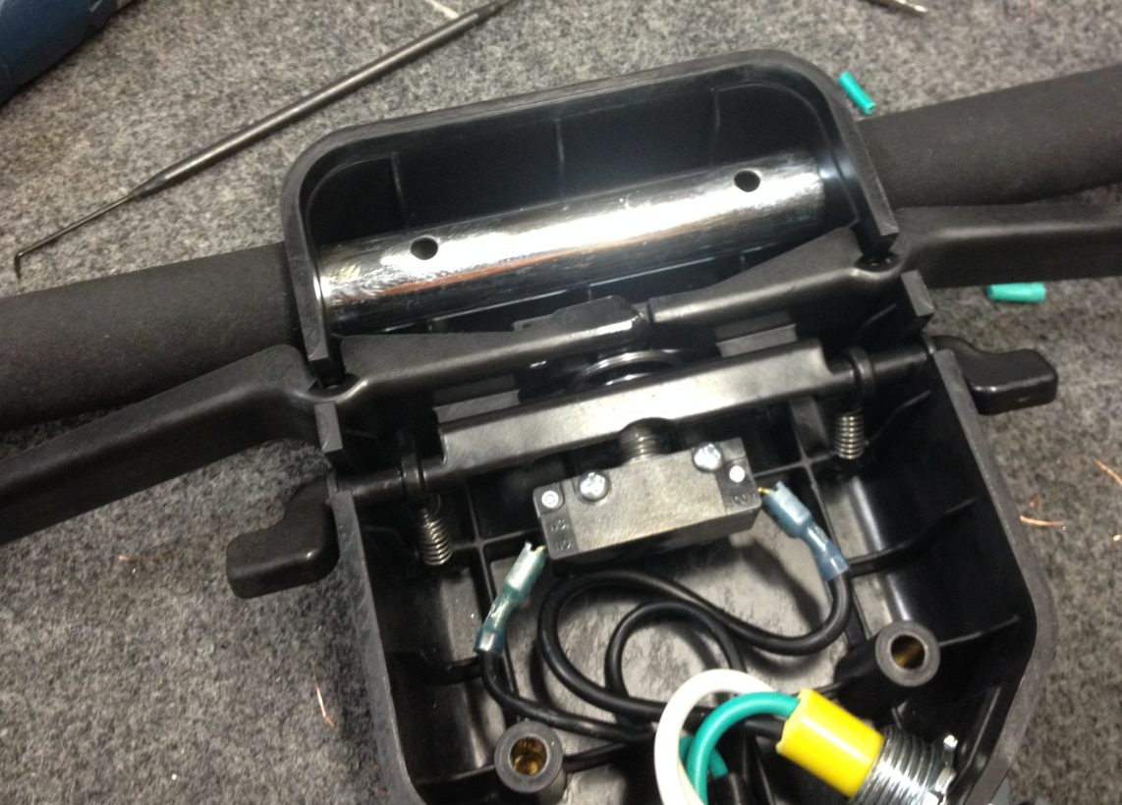

  - Line the holes in the handle tube with the holes in the box. Place the switch box cover (82751) over the back of the box. Fasten the cover on using 4 of screw (83426).

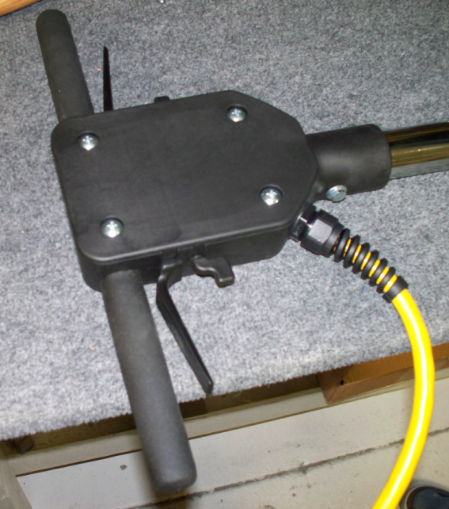

  - Place the safety decal (83691) on the back of the handle cover.

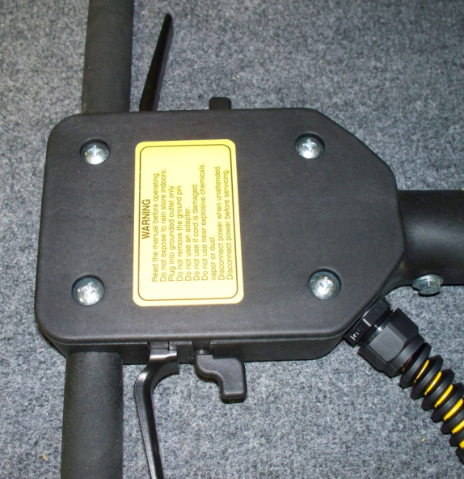

- References (optional section as needed)

- Training Guide

Functional Training Groups Requiring Training

- SOP Change Control

Date of Change | Reason for Change
Rev 01- 12/19/2013 | This is the first version of the S.O.P. hence there are no revisions to this document.
Rev 02 - 12/7/2017 | Updated for the new handle trigger mechanism and new handle tube.
Rev 03 – 11/12/2025 | Removed work center note and added switch bracket instructions. Also combined with Dual Speed handle

Approvals

Submitter/Author Approval:__________________________________ Date:______________________

Management Approval:______________________________________ Date:______________________

QAU Approval:_____________________________________________ Date:______________________

